Job description and employee specification
Job title: | Senior Building Control Surveyor | Location: | Municipal Offices
Reports to: | Principal Building Control Surveyor | Working hours: | 37 per week
Job number: | TBC | Salary grade: | Grade J (£48,738-£54,229)
Supervises: | Supervising and mentoring Building Control Surveyor
Purpose: | This role will be in line with, and minimum of, Class 2D building inspectors, as defined by the  Building Safety Regulator (BSR). You will perform restricted activities and advise on restricted  functions within the limitations of your registration but work towards Class 3.  As a registered building inspector. you will work on those appropriate to your competence  and the limitations of your registration. The building types reflect those identified within the  Building Regulations 2010 (as amended) and the Approved Documents.  The registration scheme for this class will recognise the skills, knowledge, experience and  behaviours of the individual and will relate to all building types within all Classes up to 2A-D  You will be expected to have and maintain your Class 2D Building Inspector competences as defined within the HSE Building Inspector Competence Framework throughout employment.
Key duties and responsibilities: | - Identifying, determine and taking action to secure compliance  - Providing competent advice to building control bodies and duty holders  - Acting within and maintain own competence, supporting others to do same  - Identifying and report conflicts of interest for appropriate action to be taken  - Undertaking all work in compliance with the Code of Conduct  - Assessing plans and carrying out inspections to assess whether building work is undertaken in compliance with the Building Regulations 2010 (as amended), other requirements of the Building Act 1984 (as amended) and associated legislation, standards and guidance for type of buildings as mentioned above, as defined by the Building Safety Act 2022 (amended)  These relate to the subject areas, activities, and functions within the competence framework and the ability to deliver on these in compliance with limitations within the individual’s registration.  This job description sets out the key outcomes required. It does not specify in  detail all the activities required to achieve these outcomes.  General accountabilities  - Work to add value to, and be a valued member of, the team and to be valued by  customers  - Maintain a safe working environment and ensuring, as reasonably practicable, that safe  working practices are adopted by employees within the working environment  - Work in compliance with the codes of conduct, regulations (including financial) and policies of the council  - Exercise proper and absolute integrity in respect of all confidential matters and the confidentiality of personal and sensitive information  - Show a commitment to safeguarding the welfare of vulnerable adults, young people and children, in line with the organisation’s policy  - Any other tasks or activities that may be deemed appropriate by senior management.

Organisational Values: | Work to and help embed our organisational values:  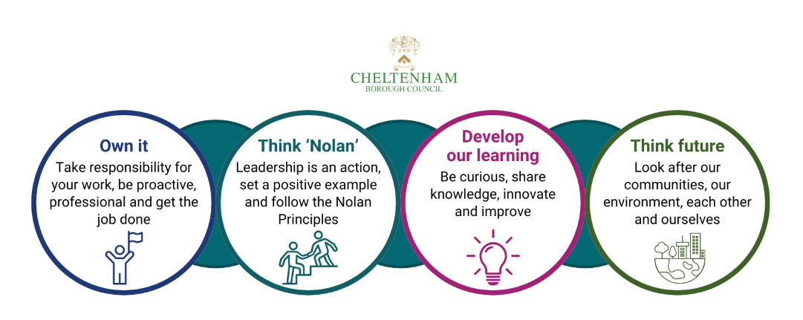
Essential requirements - qualifications, skills, abilities and experience: | Qualifications  - Registered as a minimum Class 2D Building Inspector  - Level 4-6 academic qualification or equivalent, relevant professional/vocational training  - Sufficient knowledge to contribute to the demonstration of competence against the BICoF, relevant legislation, approved documents and guidance  - Fire/life safety  - Health and safety  - Design and construction.  Experience  - Assessing compliance against the Building Act 1984 (as amended), Building Regulations 2010 (as amended) and other applicable, allied legislation, standards and guidance  - Previous experience of the building types on which they intend to work  - Inspections  - Plans assessment  - Developing and implementing inspection schedules  - Assessing safety and risk  - Taking action to secure compliance, including enforcement action.  Skills and abilities  - Analysis of information  - Decision making  - Record keeping and report writing  - IT-proficiency  - Communicating, influencing and interpersonal skills  - Supervising and mentoring trainees  - Is customer focussed, responsive, and co-operative with customers  - Is proactive/self-motivated  - Prioritises and meets tight deadlines  - Is flexible  - Ability to maintain confidentiality in accordance with current data protection legislation.
Desirable requirements - qualifications, skills, abilities and experience: | - Commitment to developing knowledge and skills through continuing professional development (CPD)  - Commitment to acting with integrity, respect and in compliance with the Code of Conduct  - Making effective decisions  - Communicating and influencing  - Working as an individual and as part of a team  - Adaptability and resilience  - Leadership and seeing the bigger picture  - Ethical and inclusive behaviours.

Special conditions: | - There may be a requirement to work at other locations to meet the needs of the business.  - Expected to work reasonable additional hours in line with the needs of the service.  - You will need use of a car for work purposes.
Date created: | 02.08.23 | Ian Smith, Head of Building Control
Date reviewed: | 10.03.2026

